Lahore Garrison University
DHA Phase 6 Lahore



Student Name | Muneeb Ur Rehman
Student Roll No | Fa-2023-BSCS-490
Section | D
Subject | Web Technology
Instructor Name | Muhammad Yousaf

🛠️ Lab 7: Responsive Design with Flexbox & Bootstrap Guide
This lab requires you to upgrade a static HTML layout into a modern, responsive design using three powerful tools: Flexbox, Media Queries, and Bootstrap.

Task 1: Convert a Static Layout to a Flexbox Layout
You will apply display: flex; to the main container to manage the positioning of the header, content, sidebar, and footer.

Conceptual HTML Structure
HTML
<body>
<header>...</header>
<div class="main-container">
<main class="content">...</main>
<aside class="sidebar">...</aside>
</div>
<footer>...</footer>
</body>

Key Flexbox CSS
- Define the Main Layout: Apply Flexbox to the container holding the main sections (content and sidebar).
CSS
.main-container {
display: flex; /* Activates Flexbox on this container */
width: 100%;
max-width: 1200px; /* Optional: Sets a max width for desktop screens */
margin: 0 auto; /* Centers the container */
}
.content {
flex: 3; /* Content takes 3 parts of the available space */
padding: 20px;
}
.sidebar {
flex: 1; /* Sidebar takes 1 part of the available space (3:1 ratio) */
padding: 20px;
background-color: #f4f4f4;
}

Task 2: Add Media Queries to Adjust Layout
The Flexbox layout above works great on a desktop. Now, you need Media Queries to stack the elements vertically for smaller screens (mobile/tablet).

Key Media Query CSS
You will target screens smaller than a tablet size (e.g., < 768px). On these smaller screens, you override the desktop Flexbox settings.
CSS
/* ---------------------------------- */
/* DEFAULT: Desktop/Tablet Flexbox Layout (from Task 1) */
/* ---------------------------------- */
.main-container {
display: flex;
/* ... other desktop styles ... */
}

/* ---------------------------------- */
/* MOBILE STYLES: Screens smaller than 768px */
/* ---------------------------------- */
@media (max-width: 768px) {
/* 1. Change the Flex direction to stack items */
.main-container {
flex-direction: column;
}

/* 2. Remove the flex ratio so content/sidebar take full width */
.content,
.sidebar {
flex: none; /* or flex: 0 0 100%; */
width: 100%;
}

/* Optional: Move the sidebar below the main content on mobile */
.sidebar {
order: 1; /* Pushes the sidebar down */
}
.content {
order: 2; /* Keeps the main content up */
}
}
- Deliverable Requirement: Ensure you take screenshots of the desktop, tablet, and mobile views to demonstrate that the layout successfully adjusts at the breakpoints defined by your media queries.

Task 3: Recreate a Component Using Bootstrap Classes
You will integrate the Bootstrap CDN and then use its utility classes to quickly style a component, like a navigation bar or a grid of portfolio cards.

A. Set up Bootstrap
Add these lines to the <head> section of your HTML file:
HTML
<link href="https://cdn.jsdelivr.net/npm/bootstrap@5.3.3/dist/css/bootstrap.min.css"
rel="stylesheet"
integrity="sha384-QWTKZyjpPEjISv5WaRU9OFeRpok6YctnYmDr5pNlyT2bRjXh0JMhjY6hW+ALEwIH"
crossorigin="anonymous">

<script src="https://cdn.jsdelivr.net/npm/bootstrap@5.3.3/dist/js/bootstrap.bundle.min.js"
integrity="sha384-YvpcrYf0tY3lHB60NNkmXc5s9fDVZLESaAA55NDzOxhy9GkcIdslK1eN7N6jIeHz"
crossorigin="anonymous"></script>

B. Example: Bootstrap Card Grid¹
Bootstrap's Grid Syst²em is built on Flexbox, making it excellent for creating responsive card layouts with minimal effort.
HTML
<section class="container my-5">
<h2 class="text-center mb-4">Portfolio Projects</h2>

<div class="row row-cols-1 row-cols-md-3 g-4">

<div class="col">
<div class="card h-100">
<div class="card-body">
<h5 class="card-title">Project Alpha</h5>
<p class="card-text">A brief description of project alpha and its technologies.</p>
<a href="#" class="btn btn-primary">View Project</a>
</div>
</div>
</div>

<div class="col">
<div class="card h-100">
<div class="card-body">
<h5 class="card-title">Project Beta</h5>
<p class="card-text">A brief description of project beta and its technologies.</p>
<a href="#" class="btn btn-primary">View Project</a>
</div>
</div>
</div>

</div>
</section>
Bootstrap Class | Purpose
.container | Provides centered, padded content area.
.my-5 | Adds margin on the Y-axis (top/bottom) for spacing.
.row | Defines a row in the Bootstrap grid.
.row-cols-1 | Mobile: Shows 1 card per row.
.row-cols-md-3 | Medium/Desktop: Shows 3 cards per row.
.g-4 | Sets the gutter (spacing) between the columns/cards.
.card | Basic Bootstrap component for a styled box.

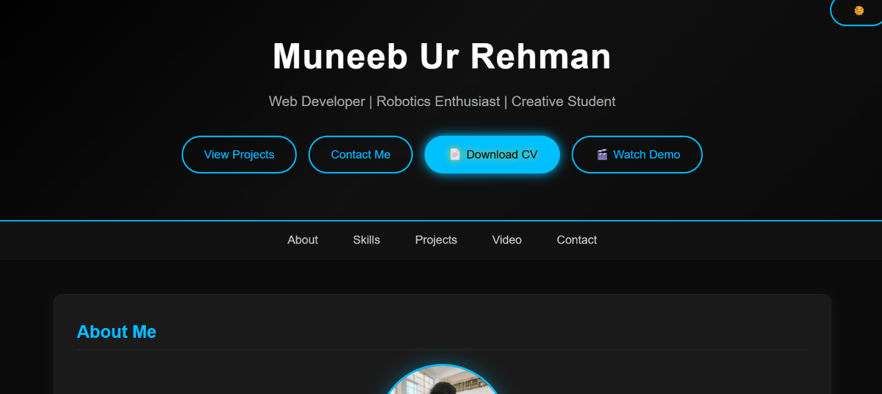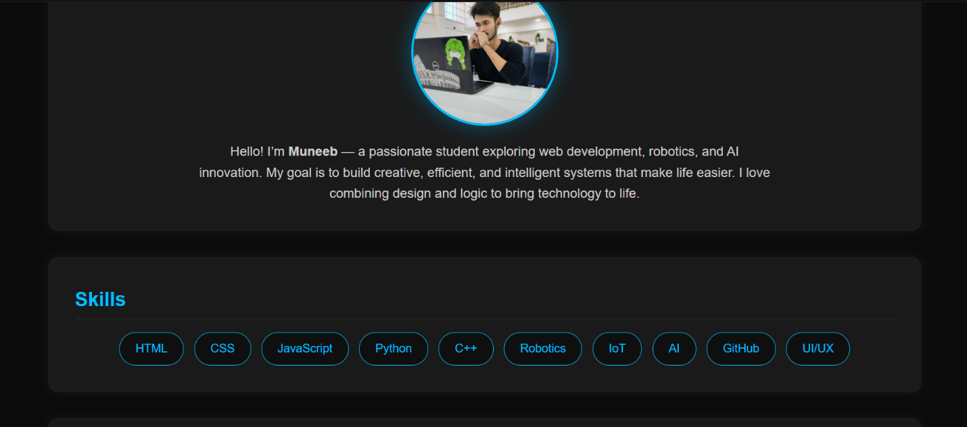

CONCLUSION:
This portfolio showcases my journey as a web developer and robotics enthusiast, highlighting my skills, projects, and creative problem-solving abilities. It reflects my passion for combining technology and design to build practical, innovative solutions. I aim to continue learning, growing, and contributing to projects that make a meaningful impact.

RUBRICS:

Performance |  |  | Lab Report
Description | Total Marks | Marks Obtained | Description | Total Marks | Marks  Obtained
Ability to Conduct practical | 5 |  | Structure | 5
Data Analysis & Interpretation | 5 |  | Efficiency | 5
Total Marks obtained |  |  | Total Marks Obtained

Instructor Signature

